In the scenario, the carwash owner has collected large amounts of data about carwash operations. Now, the business owner needs your help with analyzing data. With your help, the owner hopes to achieve the following: Analyze common patterns and trends
1.1 Identify the total number of services provided in 2023.
1.2 Identify how many services were provided during each month in 2023.
Reward hard-working staff
2.1 Identify the employee that provided the highest number of services.
2.2 (Challenge) Identify staff who received an average rating of 7 or higher.
Assess carwash services
3.1 Identify the highest-rated services.
3.2 (Challenge) Identify the lowest-rated services. To find the answers, you need to run some database queries based on the following explanations, sample queries, and desired outputs. To build the query, make sure to read each task carefully. Then, test the finalized queries in the environment that’s been prepared for you.
The environment you work in has a database table called CarwashUnit5, and it is prepopulated with records. To check the database records, in the left navigation pane, expand the Tables setting. Choose servicerecordsunit5. The database table will then display all rows and columns from the table. Additionally, you can get the complete view of all database columns and associated data types under the Structure tab in the top navigation bar.

Task 1: Analyze common patterns and trends
The carwash owner is excited to work with you. In the first task, the owner wants to know the total number of services that the carwash provided in 2023. They also want to know how many of those services were offered during each month of the year. With this information, the owner can fix staffing issues during the months with the highest demand.
Problem 1.1: Identify the total number of services provided in 2023
SELECT
COUNT(servicetype)
AS Totalservice
FROM servicerecordsunit5
WHERE servicedate BETWEEN '2023-01-01' AND '2023-12-31';

The output for problem 1.1:
TotalServices
93
The total number of services provided in 2023 is 93.

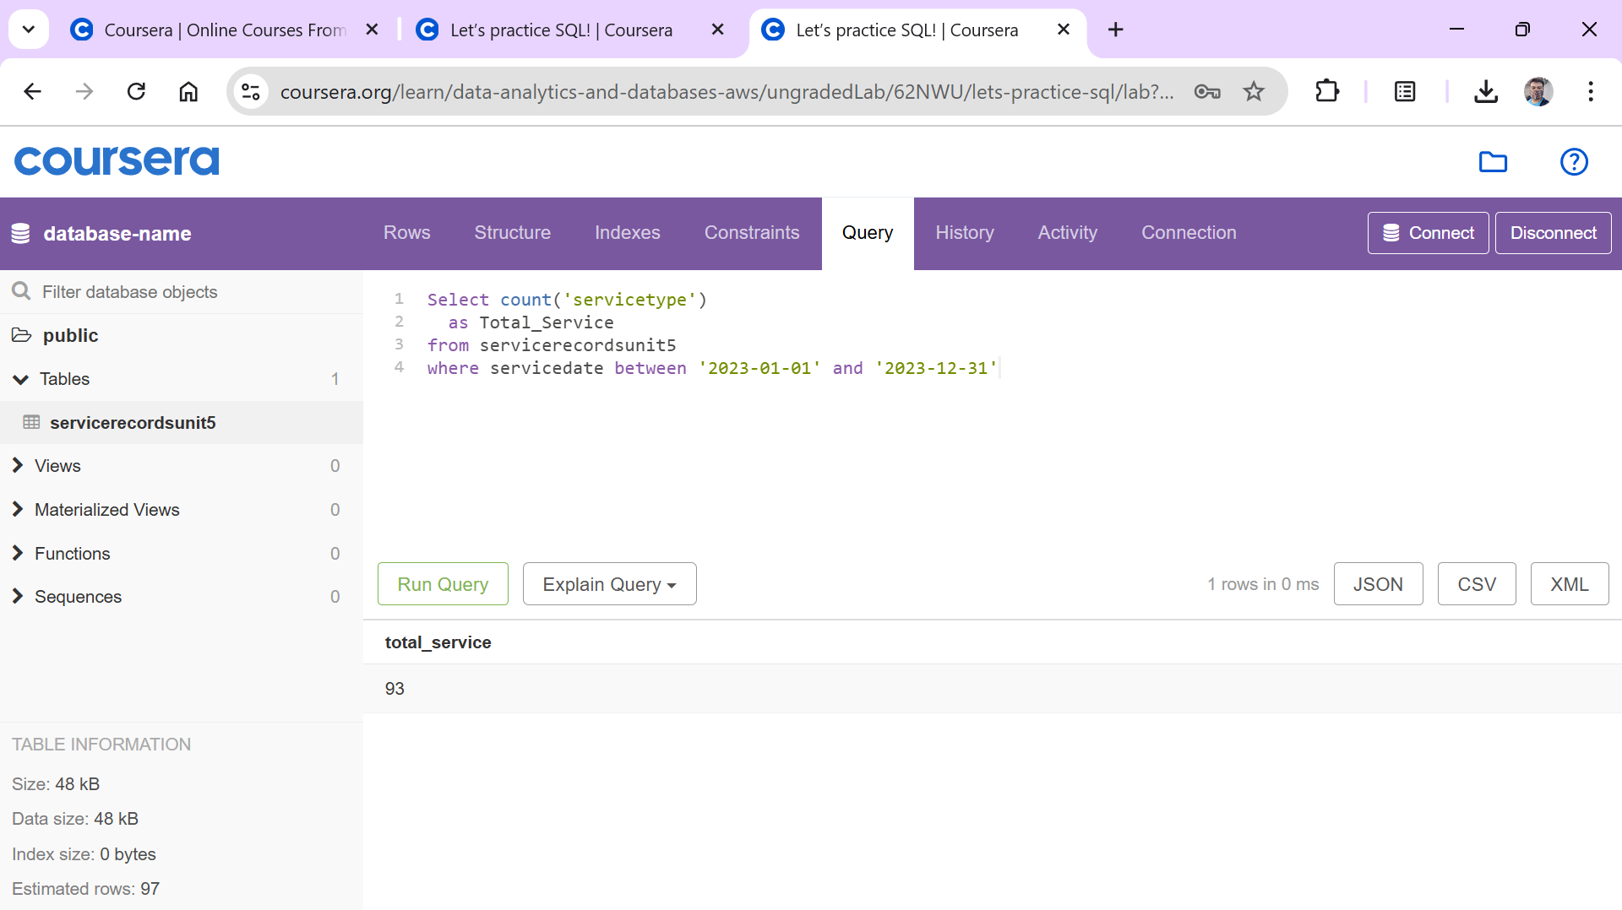

Problem 1.2: Identify how many services were provided during each month in 2023.
SELECT
EXTRACT(MONTH FROM servicedate ) AS Month,
COUNT(<servicetype) AS TotalServices
FROM servicerecordsunit5
WHERE servicedate BETWEEN '2023-01-01' AND '2023-12-31'
GROUP BY Month;

The output for problem 1.2:
Month | Total Services
1 | 4
2 | 3
3 | 6
4 | 5
5 | 8
6 | 14
7 | 21
8 | 14
9 | 9
10 | 9

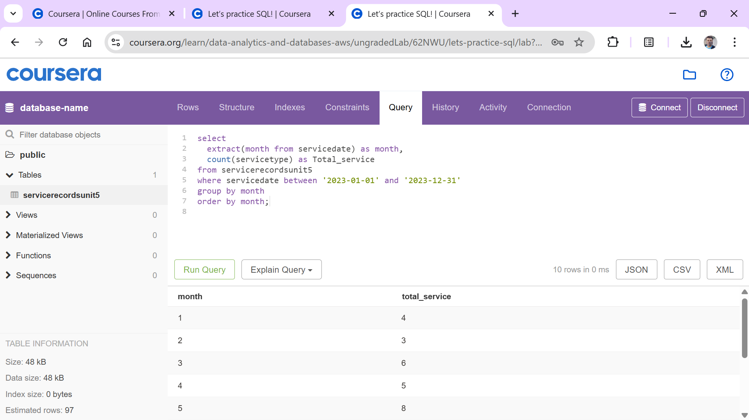

Problem 2.1: Identify staff who provided the highest number of services
To resolve this problem, your query can return the names of all employees, along with the number of services they provided. Then, you can sort the data in descending order to find out who provided the highest number of services.
SELECT EmployeeName, EmployeeID,
COUNT(servicetype) AS TotalServices
FROM servicerecordunit5
GROUP BY EmployeeName, EmployeeID
ORDER BY TotalServices DESC;
The output for problem 2.1:
EmployeeName | EmployeeID | TotalServices
Mary Major | 18193 | 21
Terry Whitlock | 65432 | 16
Sofia Martinez | 14343 | 13
Zhang Wei | 76543 | 13
John Doe | 45841 | 12
Richard Roe | 77142 | 12
Saanvi Sarkar | 92183 | 10

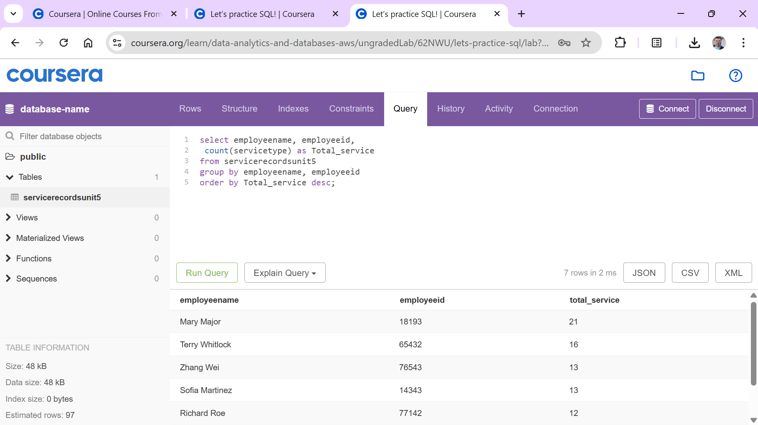
Problem 2.2: Identify staff who received an average rating of 7 or higher
select employeename, employeeid,
round(avg(servicerating),2) as rating
from servicerecordsunit5
group by employeeid, employeename
having avg(servicerating) >= 7
order by rating desc
The output for problem 2.2:
EmployeeName | EmployeeID | TotalServices | AvgRating
Mary Major | 18193 | 21 | 9
Terry Whitlock | 65432 | 16 | 9
Zhang Wei | 76543 | 13 | 8.8
Richard Roe | 77142 | 12 | 7.9
Sofia Martinez | 14343 | 11 | 8.8
Saanvi Sarkar | 92183 | 9 | 8.4
John Doe | 45841 | 6 | 7.3

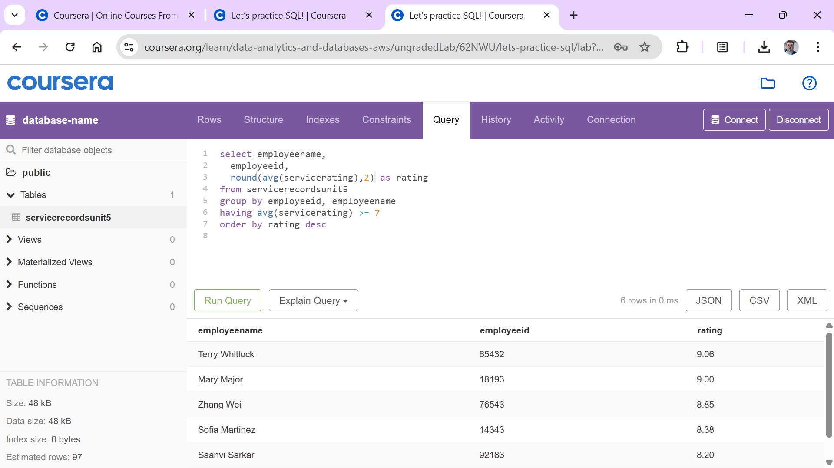

Reassess carwash offerings
Problem 3.1: Identify the highest-rated services.
select *
From servicerecordsunit5
where servicerating = (select max(servicerating) from servicerecordsunit5)
The output for problem 3.1:
CustomerID | CustomerName | CustomerPhoneNumber | ServiceRating | CustomerComments | EmployeeID | EmployeeName | ServiceType | ServiceDate
3250 | Mateo Jackson | 555-3113 | 10 | The automatic car wash left my car sparkling clean! | 65432 | Terry Whitlock | Automatic Car Wash | 3/10/2023
3487 | Jane Doe | 555-0220 | 10 | Fast and thorough car wash experience. | 14343 | Sofia Martinez | Premium Full Service | 3/5/2023
5454 | María García | 555-3193 | 10 | Car wash staff were friendly and attentive to my requests. | 77142 | Richard Roe | Self-Service Car Wash | 4/4/2023
1751 | Martha Rivera | 555-0112 | 10 | They even cleaned the mats during the self-service wash! | 65432 | Terry Whitlock | Self-Service Car Wash | 6/12/2023
1158 | Kwesi Manu | 555-0111 | 10 | Great service! | 6543 | Terry Whitlock | Automatic Car Wash | 7/22/2023
1751 | Martha Rivera | 555-0112 | 10 | Great attention to detail! | 77142 | Richard Roe | Automatic Car Wash | 8/19/2023
3959 | Pat Candella | 555-3173 | 10 | Great service! | 65432 | Terry Whitlock | Automatic Car Wash | 8/9/2023
1158 | Kwesi Manu | 555-0111 | 10 | Great attention to detail! | 18193 | Mary Major | Self-Service Car Wash | 9/12/2023
8654 | Liu Jie | 555-0223 | 10 | Love this place! | 76543 | Zhang Wei | Self-Service Car Wash | 8/16/2023
3272 | Nikki Wolf | 555-0108 | 10 | Great value for a premium full service car wash. | 18193 | Mary Major | Premium Full Service | 8/29/2023
3250 | Mateo Jackson | 555-3113 | 10 | Hand car wash was meticulous. My car looks brand new! | 18193 | Mary Major | Hand Car Wash | 7/1/2023
1751 | Martha Rivera | 555-0112 | 10 | Quick and efficient self-service car wash option. | 92183 | Saanvi Sarkar | Self-Service Car Wash | 5/30/2023
3959 | Pat Candella | 555-3173 | 10 | Love this place! | 18193 | Mary Major | Car Detailing | 7/15/2023
3272 | Nikki Wolf | 555-0108 | 10 | Great attention to detail! | 18193 | Mary Major | Full Service | 2/12/2023
3263 | Arnav Desai | 555-0161 | 10 | The vacuum service was powerful, just missed a small corner of the trunk. | 65432 | Terry Whitlock | Car Detailing | 12/29/2022
3263 | Arnav Desai | 555-0103 | 10 | Excellent vacuuming. Got rid of all the pet hair. | 14343 | Sofia Martinez | Vacuum | 10/20/2023
7750 | Li Juan | 555-0219 | 10 | Great! | 76543 | Zhang Wei | Automatic Car Wash | 8/2/2023
1453 | John Stiles | 555-0114 | 10 | Nice carwash | 18193 | Mary Major | Self-Service Car Wash | 5/3/2023
3263 | Arnav Desai | 555-0217 | 10 | Vacuum service was great. My cars interior feels fresh. | 65432 | Terry Whitlock | Vacuum | 7/9/2023
7750 | Li Juan | 555-0219 | 10 | Full service was worth it. They cleaned every detail. | 76543 | Zhang Wei | Premium Full Service | 7/11/2023
3487 | Jane Doe | 555-0220 | 10 | Everyone is so nice here. | 14343 | Sofia Martinez | Waxing | 7/2/2023
2254 | Márcia Oliveira | 555-0174 | 10 | Great value for the price | 18193 | Mary Major | Self-Service Car Wash | 7/3/2023
1158 | Kwesi Manu | 555-0111 | 10 | Premium full service was a treat. My car never looked better. | 18193 | Mary Major | Premium Full Service | 10/4/2023
3272 | Nikki Wolf | 555-0108 | 10 | Top-notch service. My car feels like new again. | 65432 | Terry Whitlock | Automatic Car Wash | 10/10/2023
3263 | Arnav Desai | 555-0103 | 10 | Superb job on my SUV. It is shining inside and out. | 76543 | Zhang Wei | Car Detailing | 10/9/2023
3250 | Mateo Jackson | 555-3113 | 10 | Excellent service! | 92183 | Saanvi Sarkar | Full Service | 10/24/2023

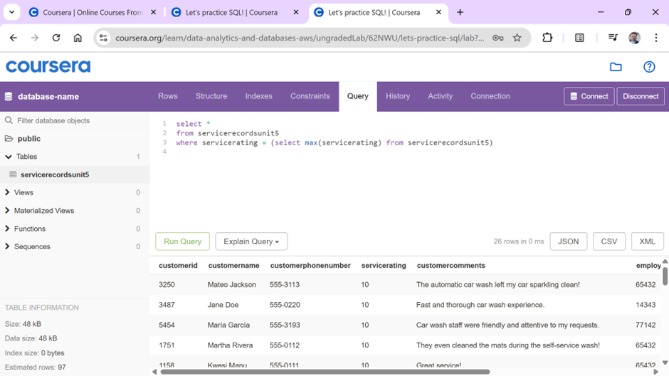

Problem 3.2: Identify the lowest-rated services.
The output for problem 3.2:
select *
From servicerecordsunit5
where servicerating = (select min(servicerating) from servicerecordsunits)
CustomerID | CustomerName | CustomerPhoneNumber | ServiceRating | CustomerComments | EmployeeID | EmployeeName | ServiceType | ServiceDate
3478 | Alejandro Rosalez | 555-0106 | 4 | The wash was uneven on my SUV. | 45841 | John Doe | Automatic Car Wash | 2/25/2023
5454 | María García | 555-3193 | 4 | Car wash attendants could be more attentive. | 45841 | John Doe | Automatic Car Wash | 9/7/2023
